Traveling Salesman: An NFL Scheduling Problem

David Graves
Colorado State University Global
CSC506
Dr. Brian Holbert
April 22, 2025

Wrapping up the Experiment
Now that I’ve been able to run all three algorithms against the different data sets it’s helpful to review the results and performance to understand how well each one worked through the problem presented. Leaning on Agile methodology, I’ll also take the opportunity to iterate and optimize where possible and share results from any new updated algorithms and how they perform on the same tests as earlier. In taking the iterative development approach it, “means improvements are made on an ongoing basis, so the end result is likely to be delivered on time and be of higher quality.” (Gurnov, 2025). I’ll use the remainder of this paper to share initial analysis, change log, and final analysis of performance including commentary on space and time complexity needs for each algorithm.
Analysis and Optimization
As a reminder this project looked to explore how three different algorithms attempted to solve the traveling salesman problem for the Denver Broncos in trying to find the shortest route to take when visiting various other NFL teams. The initial test included running the same data sets (A = AFC West, B = AFC West + AFC East, & C = AFC West + AFC East + AFC South) through each algorithm to produce ideal maps based on shortest trip in miles. In addition to the actual ‘best’ map produced each algorithm was timed to understand any performance issues there as well. The three algorithms developed and implemented for this exercise were Nearest Neighbor, Minimum Spanning Tree, and Genetic. The maps that were used are shown below in Image 1 for reference, and each algorithm’s performance across the data sets is displayed below in Image 2 below.

Image 1 - Map with Teams
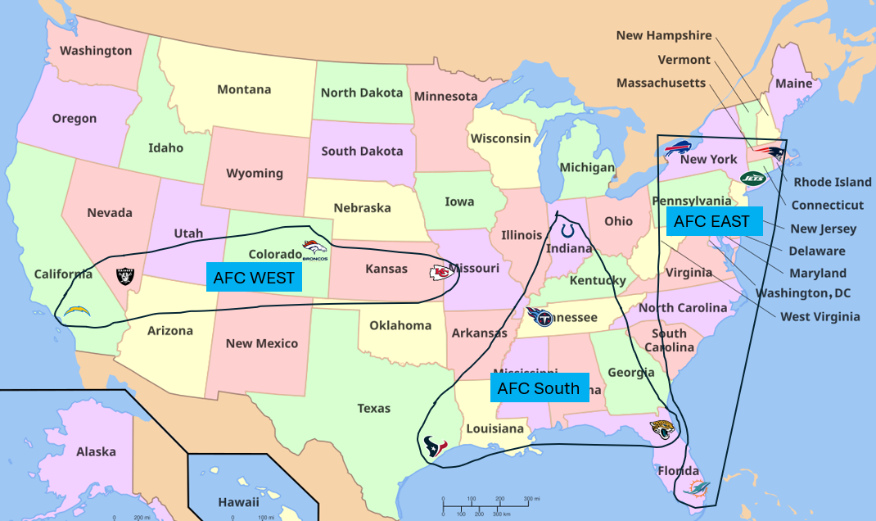
Image 2 - Results Table
In reviewing each algorithm’s performance across the data sets in the table above I’m happy to see some consistency in results which leads me to believe that they are 1. all working as intended and 2. the results seem to fit what I would have expected. The Nearest Neighbor was the fastest algorithm with Minimum Spanning Tree coming in a close second and the Genetic algorithm was considerably longer, especially with the larger data sets. The interesting results were in the different solutions each algorithm found across the maps. All three found the same distance for the smallest data set (A – 4 city), but the Genetic map sent the Broncos west to Las Vegas first whereas the other two had them starting their travel in Kansas City. With the medium sized data set (B – 8 city trip) the Nearest Neighbor gave the shortest trip followed by Genetic and finally the Minimum Spanning Tree had them travel the farthest. The Minimum Spanning Tree ended up finding the shortest trip for the largest data set (C – 12 city) followed by the Genetic and the least optimal solution was produced by the Nearest Neighbor algorithm. In summation each one produced the shortest route for at least one of the data sets and performed the worst on one too. In practice, if one has a small to medium data set, I recommend using the Nearest Neighbor since it produces the best map in the quickest amount of time and as the destination list grows the Minimum Spanning Tree produces the better map with a little more time spent than the Nearest Neighbor. In this experiment the Genetic algorithm produced the most lack-luster results, however I believe that may be due to the maps being less complex. It did great with the medium-sized data set, but at a massive cost in time with 1.3282 seconds verses the Nearest Neighbor at .0006 seconds. One expected advantage of the Genetic algorithm is that it should find potentially optimal solutions for large and complex maps, which this may just not have been. One iterative change that I ran for this exercise was changing some of the parameters in the Genetic Algorithm for the large data set run to see if it could produce better results with different variables. Changing the generation to a smaller number 250 from 500 produced the best map across all models for the 12-city trip sending the Broncos traveling for 6,999 miles instead of the 8,787 miles they had to previously go, and it did it in half the original time at .6417 seconds. One additional note is that when I ran this algorithm multiple times it produced different results with each run of the same data with the same parameters, most likely due to the mutation rate. The working algorithm and its results are shared below in Image 3.
Image 3 - Genetic Data Set C 12-city (Less Generations)


Reflection
As mentioned in the discourse above I think all the algorithms performed how they were meant to with the different size data sets I fed them. The Genetic algorithm is the true wild card with scattered results based off the inputs for ‘generation’, ‘population’, and ‘mutation’. That said, I was able to see the results I would have expected prior to running the experiment for all three models. The most interesting part of this exercise was playing with the variables for the Genetic algorithm. I saw where logically, as I increased the generations, the time spent to solution increased, and as I increased the mutation rate, I saw more variance in the map results. I think as future iteration ideas that the Nearest Neighbor and MST wouldn’t require any change for small and medium data sets, and that one would want to “dial in” the Genetic variables to find the most efficient and shortest trip solutions if using a large and complex map.

Reference
Gurnov, Artem (2025, April 14). Wrike.com. What is Iterative and Incremental Development?
https://www.wrike.com/project-management-guide/faq/what-is-iterative-incremental-development/

